
Short courses for Permanent Missions in Geneva
Governance, development and LDCs
Friday 18 March 2011
SPEAKER
Biographical notes

Charles Gore is Head of the Research and Policy Analysis Branch in the Division for Africa, Least Developed Countries and Special Programmes in UNCTAD.

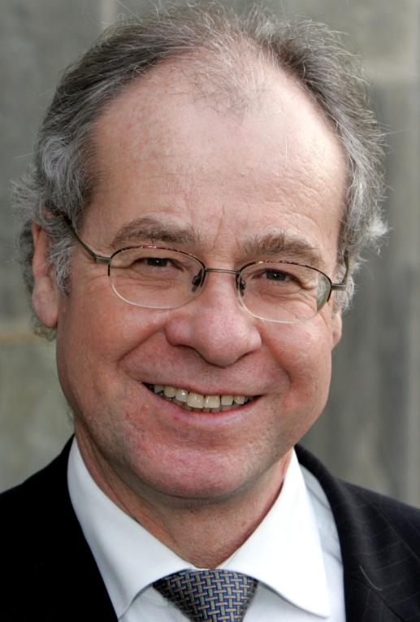
Originally trained in economic geography, he holds an undergraduate degree from Cambridge University (1971), and a doctorate from Pennsylvania State University (1978) which was based on two-year's local fieldwork on the economic organization of food marketing in Ghana. He has over thirty years experience in international development with a primary focus on globalization, development strategies and poverty. He was employed as a Lecturer in Development Studies at the University of Wales from 1976 to 1991, and first worked as a consultant for UNCTAD in 1984, proposing an analytical framework for conceptualizing the problem of landlocked countries as a development problem. He contributed to UNCTAD's initial discussion of the concept of sustainable development in 1992; he helped formulate UNCTAD's initial understanding of East Asian development success in 1994; he co-managed an ILO multi-country research project applying the concept of social exclusion in a global context in ILO in 1995 and 1996; and he co-managed a multi-country research project on lessons of East Asian development for Africa from 1997 to 1999. Between 1999 and 2008, he directed the research for UNCTAD's Least Developed Countries Report.

He is the author or editor of a number of books and has published various articles. His paper, “The Rise and Fall of the Washington Consensus as a Paradigm for Developing Countries”, which was published in 2000, was one of the top ten most downloaded articles between 2005 and 2010 in World Development, the leading development studies journal. His first book, Regions in Question: Space, Development Theory and Policy, originally published in 1984, has just been re-issued in the Routledge Revivals series, which is dedicated to restoring influential authors and books of the last 120 years which have gone out of print.

He was a member of the UN Experts Group of the UN Millennium Project on MDGs. He is presently a member of the Academic Council of the Swiss Network for International Studies and a member of the Council of the UK Development Studies Association. He was appointed Honorary Professor of Economics at the University of Glasgow, Scotland, in 2008.

