
Short courses for Permanent Missions in Geneva
Reform of the International financial architecture
Monday 3 October 2011
PRESENTERS
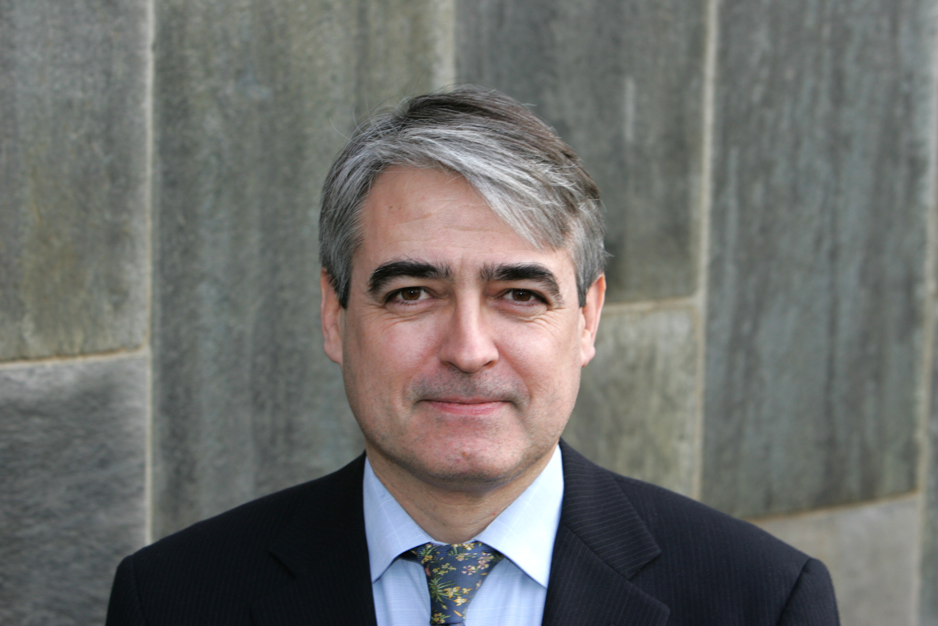
Alfredo F. Calcagno is an Argentinean economist. He holds a PhD in Economic Sciences from the University of Paris I. In Argentina, he worked at the Ministry of Economy (1984-85), the Central Bank (1986-87) and the Centre of International Economy (1988-89). He was also Professor of Economics at the National University of La Plata (1986-1989). In 1989 he jointed the United Nations as Economic Affairs Officer at ECLAC (Economic Commission for Latin America and the Caribbean). In 2003, he joined the Division of Globalization and Development Strategies at UNCTAD.

He is the author several works: “In search of another form of development”, CEPAL Review, December 1992 (with Pedro Sáinz), El universo neoliberal, Siglo XXI, Buenos Aires, 2006 (with A.E. Calcagno), “Convertibility and the banking system in Argentina”, CEPAL Review, April 1997, La economía brasileña ante el Plan Real y su crisis, CEPAL, July 1999 (with Pedro Sainz). He is co-author of several institutional documents, and coordinated the preparation of the Preliminary Overview of the Economies of Latin America and the Caribbean 2002 and the Economic Survey of Latin America and the Caribbean 2002-2003. At present, he is part of the team that prepares the UNCTAD Trade and Development Report.

Ugo Panizza is the Chief of the Debt and Finance Analysis Unit in the Division on Globalization and Development Strategies of UNCTAD. He is also Lecturer at the Graduate Institute of International and Development Studies at the University of Geneva, where he teaches econometrics and development economics. Prior to joining UNCTAD, Ugo was a Senior Economist in the Research Department of the Inter-American Development Bank (1998-2006). He also worked in the Africa Region at the World Bank and was an Assistant Professor in the Department of Economics at the University of Torino and the Department of Economics at the American University of Beirut.

Ugo has published more than 50 papers in professional journals and edited volumes and two books on the Latin American debt and bond markets. His research interests include international finance, sovereign debt, banking, political economy, and public sector labor markets. Ugo holds an undergraduate degree from the University of Torino and a Ph. D. in Economics from the Johns Hopkins University (Baltimore). Ugo's papers and publications can be downloaded at: http://upanizza.googlepages.com/

