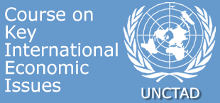
Short courses for Permanent Missions in Geneva
Global economic crisis: causes, consequences and possible ways out
Friday 3 April 2009
PROGRAMME
Geneva, Palais des Nations |  | Room XXVI
10:00 - 10:05 | Welcome
10:05 - 11:25 | The global economic crisis: what went wrong  Followed by an interactive discussion  Heiner FLASSBECK, Director, Division on Globalization and Development Strategies (GDS)
11:25 - 11:40 | Coffee break
11:40 - 13:00 | Systemic failures and multilateral remedies  Followed by an interactive discussion  Heiner FLASSBECK, Director, Division on Globalization and Development Strategies (GDS)

