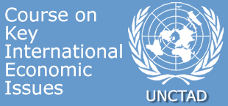

Short courses for Permanent Missions in Geneva
Bridging the technology gap
Friday 24 April 2009
SPEAKERS

Biographical notes

Ms. Kathy Stokes is an Economic Affairs Officer in the Science and Technology Section of the Division on Technology and Logistics of UNCTAD, where she participates in a range of activities relating to science, technology and innovation policy. Following a first career as a systems analyst, she spent some years at the University of Strathclyde, UK, teaching and carrying out research in technology policy and sustainable development. Her area of expertise is in the analysis of innovation systems, and the assessment of technological capacity. She has a special interest in biotechnology, and has carried out country-level research on a range of biotechnology policy issues in developing countries, including inward technology transfer, Intellectual Property Rights, biosafety, and capacity-building for biotechnology in agriculture and health.

Ms. Stokes first came to UNCTAD in the year 2000, to provide short-term technical support to the Commission on Science and Technology for Development for their 1999-2001 biennial programme on National Capacity-Building in Biotechnology. More recently, she has participated as a consultant on two of UNCTAD's Science, Technology and Innovation Policy (STIP) Reviews, and was the lead author of the UNDP's Kosovo Human Development Report 2007: Energy and Human Development. Since October 2008 she has been working full time at UNCTAD, again supporting the work of the Commission, and also contributing to the Division's new Technology & Innovation Report.

