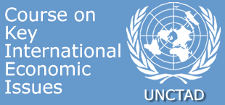
Short courses for Permanent Missions in Geneva
Bridging the technology gap
Friday 24 April 2009
PROGRAMME
Geneva, Palais des Nations |  | Room IX
10:00 - 10:05 | Welcome
10:05 - 11:25 | Technology transfer: from global markets to end-users  Followed by an interactive discussion  Kathy Stokes, Science & Technology Section, Division on Technology and Logistics
11:25 - 11:40 | Coffee break
11:40 - 13:00 | Implications for science, technology and innovation policy  Followed by an interactive discussion  Kathy Stokes, Science & Technology Section, Division on Technology and Logistics

