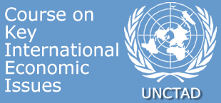
Short courses for Permanent Missions in Geneva
Investment promotion
Tuesday 9 June 2009
PROGRAMME
Geneva, Palais des Nations |  | Room XXI
10:00 - 10:05 | Welcome
10:05 - 11:00  11:00 - 11:15 | Investment promotion in times of economic crisis  Followed by an interactive discussion  Paul Wessendorp, Chief, Investment Facilitation Section, Division on Investment and Enterprise (DIAE)
11:15 - 11:30 | Coffee break
11:40 - 13:00 | Overview of :  - Investment decision making process  - Investor targeting process: case study  - Action plans for diplomats  Followed by an interactive discussion  Natalia Guerra, Programme Officer and Training Coordinator, Investment Facilitation Section, Division on Investment and Enterprise (DIAE)

